Syntax Analysis

📐 What is Syntax Analysis?
# Source: AI Source: Provided by: [Data Path: Persons Table -> ID Column: 1, Name_En Column: Motasem Essam] -> From: [Chatgpt (GPT‑5 Mini)] on [12/9/2025]
Syntax analysis, also called parsing, is the second stage of compilation, right after lexical analysis. It takes the stream of tokens from the lexer and builds a structured tree based on the grammar of the programming language.

🔹 Key Idea:
# Source: AI Source: Provided by: [Data Path: Persons Table -> ID Column: 1, Name_En Column: Motasem Essam] -> From: [Chatgpt (GPT‑5 Mini)] on [12/9/2025]
Syntax analysis checks "Does the structure of this code make sense?"
It ensures that the tokens are arranged legally — according to the rules of the language, known as the context-free grammar (CFG).

📦 Example Flow
# Source: AI Source: Provided by: [Data Path: Persons Table -> ID Column: 1, Name_En Column: Motasem Essam] -> From: [Chatgpt (GPT‑5 Mini)] on [12/9/2025]
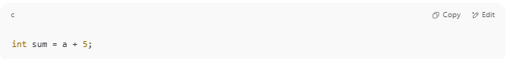
int sum = a + 5;

🧩 Lexical Analysis produces tokens:
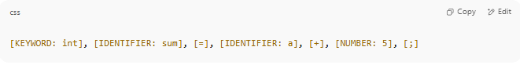
[KEYWORD: int], [IDENTIFIER: sum], [=], [IDENTIFIER: a], [+], [NUMBER: 5], [;]

🧩 Syntax Analysis builds a structure (parse tree or AST):
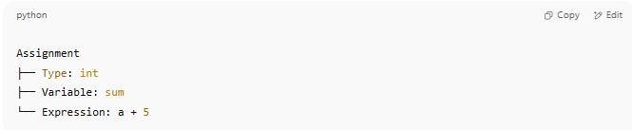
Assignment
├── Type: int
├── Variable: sum
└── Expression: a + 5

🔧 What the Syntax Analyzer (Parser) Does
# Source: AI Source: Provided by: [Data Path: Persons Table -> ID Column: 1, Name_En Column: Motasem Essam] -> From: [Chatgpt (GPT‑5 Mini)] on [12/9/2025]
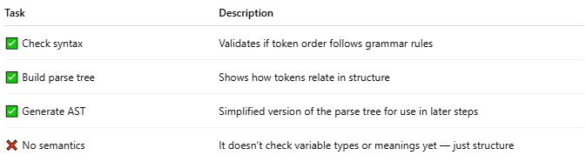
Task | Description
✅ Check syntax | Validates if token order follows grammar rules
✅ Build parse tree | Shows how tokens relate in structure
✅ Generate AST | Simplified version of the parse tree for use in later steps
❌ No semantics | It doesn’t check variable types or meanings yet — just structure

🌳 Output Structures
# Source: AI Source: Provided by: [Data Path: Persons Table -> ID Column: 1, Name_En Column: Motasem Essam] -> From: [Chatgpt (GPT‑5 Mini)] on [12/9/2025]
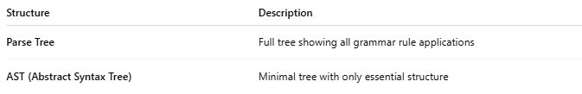
Structure | Description
Parse Tree | Full tree showing all grammar rule applications
AST (Abstract Syntax Tree) | Minimal tree with only essential structure

🧠 Example: Parsing an Expression
# Source: AI Source: Provided by: [Data Path: Persons Table -> ID Column: 1, Name_En Column: Motasem Essam] -> From: [Chatgpt (GPT‑5 Mini)] on [12/9/2025]
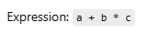
Expression: a + b * c

Parse Tree (Shows every rule):
# Source: AI Source: Provided by: [Data Path: Persons Table -> ID Column: 1, Name_En Column: Motasem Essam] -> From: [Chatgpt (GPT‑5 Mini)] on [12/9/2025]
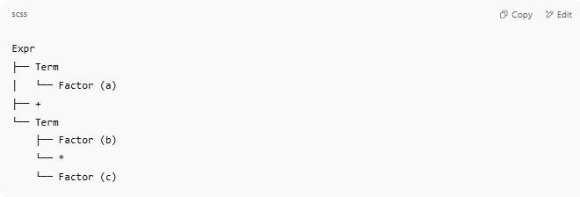
Expr
├── Term
│ └── Factor (a)
├── +
└── Term
├── Factor (b)
└── *
└── Factor (c)

AST (Stripped-down version):
# Source: AI Source: Provided by: [Data Path: Persons Table -> ID Column: 1, Name_En Column: Motasem Essam] -> From: [Chatgpt (GPT‑5 Mini)] on [12/9/2025]
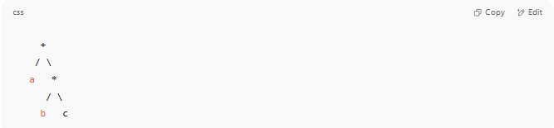
+
/ \
a *
/ \
b c

🛠️ Types of Syntax Parsers
# Source: AI Source: Provided by: [Data Path: Persons Table -> ID Column: 1, Name_En Column: Motasem Essam] -> From: [Chatgpt (GPT‑5 Mini)] on [12/9/2025]
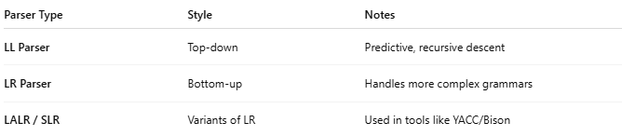
Parser Type | Style | Notes
LL Parser | Top-down | Predictive, recursive descent
LR Parser | Bottom-up | Handles more complex grammars
LALR / SLR | Variants of LR | Used in tools like YACC/Bison

✅ Why Syntax Analysis Matters
# Source: AI Source: Provided by: [Data Path: Persons Table -> ID Column: 1, Name_En Column: Motasem Essam] -> From: [Chatgpt (GPT‑5 Mini)] on [12/9/2025]
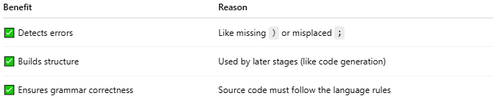
Benefit | Reason
✅ Detects errors | Like missing ) or misplaced ;
✅ Builds structure | Used by later stages (like code generation)
✅ Ensures grammar correctness | Source code must follow the language rules

⚠️ Syntax Error Example
# Source: AI Source: Provided by: [Data Path: Persons Table -> ID Column: 1, Name_En Column: Motasem Essam] -> From: [Chatgpt (GPT‑5 Mini)] on [12/9/2025]
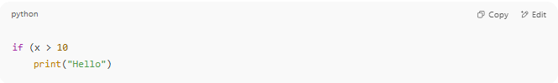
if (x > 10
print("Hello")

❌ Missing closing ) — the syntax analyzer will catch this!

📌 Summary
# Source: AI Source: Provided by: [Data Path: Persons Table -> ID Column: 1, Name_En Column: Motasem Essam] -> From: [Chatgpt (GPT‑5 Mini)] on [12/9/2025]
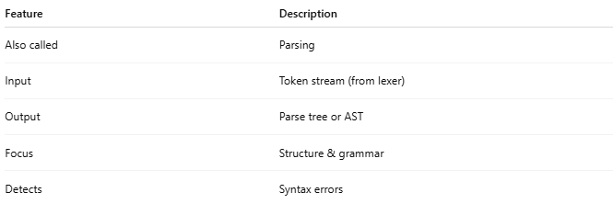
Feature | Description
Also called | Parsing
Input | Token stream (from lexer)
Output | Parse tree or AST
Focus | Structure & grammar
Detects | Syntax errors

